**Instructions for the Controlled Medication Count Sheet**

1. Each separate ‘supply’ of a controlled medication is counted. This is why the Scheduled Medication Time must be filled out. A supply of medication is:
   1. a pill bottle with one month’s supply of medication in it, used for all scheduled times that medication is to be taken.
   2. a ‘blister or bubble pack’ that holds the supply of a medication to be given at a specific time of day. If there are 2 blister/bubble packs for that *same* time of day, one count sheet may be used for both. *Medications that are packed by time given (AM and PM, or 8AM and 3PM, for example) get a count sheet for EACH time given – each time is considered a ‘supply.’*
   3. a PRN (as needed) medication supply for a client – whether the medication is in one or two bottles, or one or more blister or bubble packs – it is a single supply.
2. Controlled Medication Count sheets may be printed double sided, and in black and white (as long as the Number Remaining Verified By column remains shaded), if desired.
3. When a new supply of medication is received:
   1. fill out the top part of the count sheet, count to verify the amount received, and initial in the “received by” spot. One may initial, two is preferred but not required.
   2. the ‘start date’ is the date the medication is received – the date the sheet is ‘started’ does not have anything to do with the ‘start date’ on the MAR – this date is for the purpose of counting only.
   3. a controlled medication count sheet must be started for each controlled medication and staff should begin documenting shift counts once the medication is received, even if the medication will not be administered right away (in the case of a refill supply or PRN).
4. At this point, several different things could occur:
   1. If the medication is counted at shift count before any is administered
      1. count and enter the number remaining in the top spot in the number remaining column (this should equal the amount received).
      2. leave blank or line through the Date, Time, Name of person administering, number on hand, and number given to client columns
      3. staff on and staff off initial, and enter date/time of count in shaded column to verify that number remaining column is correct
      4. if there are subsequent counts before any medication is administered, count and initial as in step iii. Enter the correct count in the number remaining column.
      5. staff legibly print/sign their names, and initial at the bottom of the sheet (to identify initials) – only done once per sheet – or once per side if printed double sided.
   2. If the medication is administered before a shift count occurs
      1. enter date, time, name of person administering the medication on first row
      2. also enter the number on hand, the number given to the client, and the number remaining. The number remaining equals the number on hand, minus the number given. The shaded count area is NOT filled out at the time of medication administration.
      3. each time the medication is given, fill out the next line on the count sheet with date, time, name of person administering, number on hand, number given, and number remaining.
   3. If the medication is counted after having been administered during the shift
      1. staff on and staff off count the medication to verify that it is the same amount as the last entry in the number remaining column.
      2. *on the same line as the last entry* staff on and staff off enter their initials, the date, and the time. Note that the date may be different than the date the medication was given – if the count is at morning shift change and the medication was given before midnight.
5. To summarize – do not enter in last three columns when giving medications. When counting medications at shift change, the last three columns are completed, to verify the entry in the “number remaining’ column. The “number remaining” number may need to be copied from the row above if the medication was not given between counts.

**EXAMPLE – PRN MEDICATION – might be in a bottle, or a blister or bubble pack, or packs**

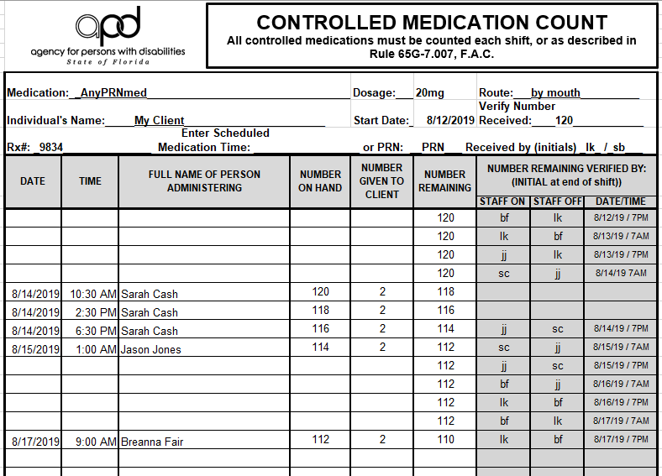

Nothing is entered in these sections when medication is **not** given between shift count times. The number remaining is copied from the row above. Shift count is documented in the last three shaded columns to verify that the amount in the number remaining column is correct.

Medication received 8/12, not given until 14th – counted 4 times before first dose administered. ‘Number received’ copied to ‘number remaining’ column for first count.

Note that nothing is in count boxes when medication **is** given between shift count times.

OR… If you prefer to use lines in unused sections – It would look like this

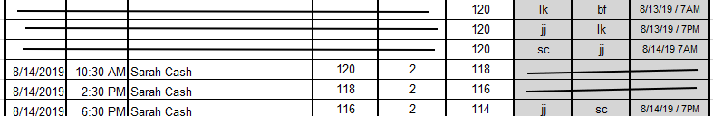

Don’t forget to enter your name, signature, and initials at the bottom!

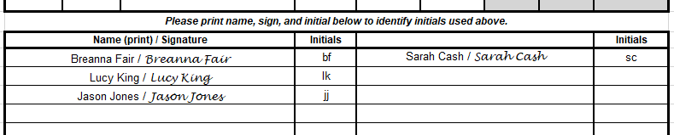

**EXAMPLE – SCHEDULED MEDICATION – any supply specific to one time of administration – could be in a bottle or blister or bubble pack**

In this example, the medication is given on only one shift, as would be the case if blister/bubble packs were used – a medication might be given once a day, or twice – but the pack for each scheduled time would have its own count sheet.

This would also be the example to use if a medication given once daily was supplied in a bottle.

HERE – the medication is **given** at 6PM. Medication is **counted** at 7PM, with shift change (twice daily, in this example).

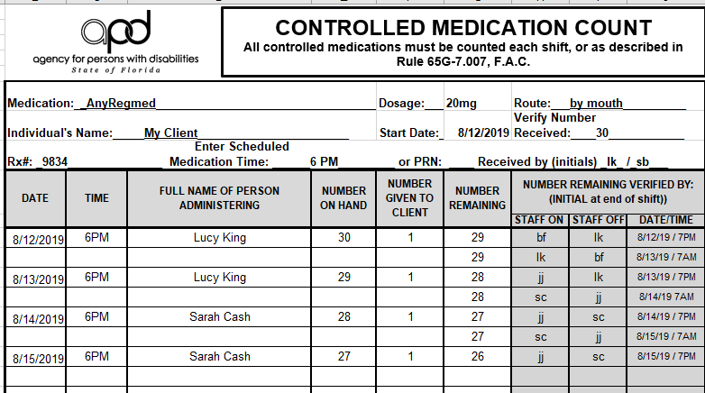

HERE – the medication is **not given** during the shift, but is **counted** at 7AM, with shift change.

Nothing is entered in these rows, because the medication was not given, but the medication is counted at shift change - the number remaining is copied from the row above, the medication is counted, and the shaded columns filled out with initials/date/time to verify that it is correct.

**Example – SCHEDULED MEDICATION – Ordered for 3 times per day, supplied in a bottle.**

Given at 8AM, 3PM, and 10PM, at a facility that works in 12-hour shifts. Note that the date on the count is not the same as the date the medication was administered for the 10PM time. This is fine – it just shows that the next count was due the next morning.

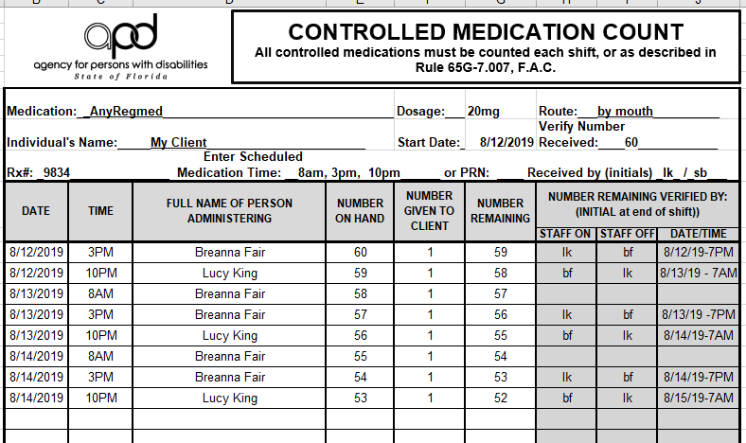

**­**

**Examples – ONE PERSON COUNTS – medication given daily at 8AM**

In this example, there are two shifts, but they don’t meet. The medication is given on one shift, but must be counted on both shifts.

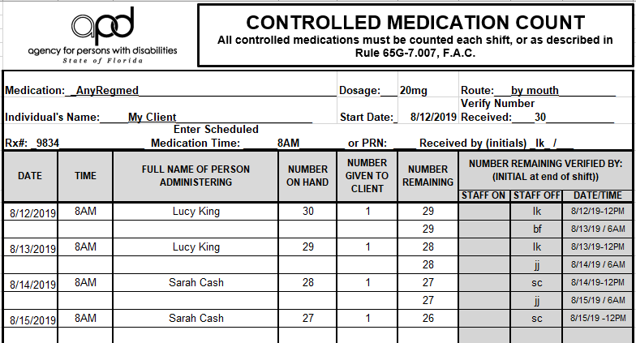

This is what this would look like if you preferred to put lines through all empty places

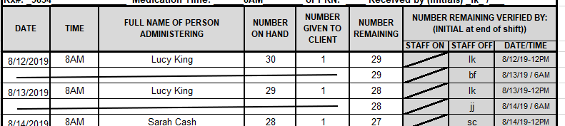

In this example, there is only one shift per day, and the medication is counted daily before the MAP leaves for the day.

